On the basis of number of strings, grammars are classified as-

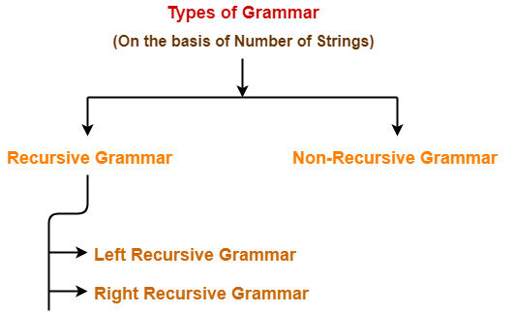

1. Recursive Grammar
2. Non-Recursive Grammar

**1. Recursive Grammar-**

* A grammar is said to be recursive if it contains at least one production that has the same variable at both its LHS and RHS.

**OR**

* A grammar is said to be recursive if and only if it generates infinite number of strings.

A recursive grammar may be either-

1. Left recursive grammar
2. Right recursive grammar

### ****A) Left Recursive Grammar-****

* A recursive grammar is said to be left recursive if the leftmost variable of RHS is same as variable of LHS.

**OR**

* A recursive grammar is said to be left recursive if it has [**Left Recursion**](https://www.gatevidyalay.com/left-recursion-left-recursion-elimination/).

### ****Example-****

S → Sa / b

**(Left Recursive Grammar)**

### ****B) Right Recursive Grammar-****

* A recursive grammar is said to be right recursive if the rightmost variable of RHS is same as variable of LHS.

**OR**

* A recursive grammar is said to be right recursive if it has right recursion.

### ****Example-****

S → aS / b

## ****2. Non-Recursive Grammar-****

* A grammar is said to be non-recursive if it contains no production that has the same variable at both its LHS and RHS.

**OR**

* A grammar is said to be non-recursive if and only if it generates finite number of strings.

|  |
| --- |
| ****NOTE**** A non-recursive grammar has neither left recursion nor right recursion. |

### ****Example-****

S → aA / bB

A → a / b

B → c / d

**(Non-Recursive Grammar)**

The language generated from this grammar is L = { aa , ab , bc , bd }

Since the grammar generates finite number of strings, therefore it is a non-recursive grammar.

## ****Important Notes-****

### ****Note-01:****

The grammar which is either left recursive or right recursive is always unambiguous.

Examples-

* S → aS / b (Unambiguous Grammar)
* S → Sa / b (Unambiguous Grammar)

### ****Note-02:****

The grammar which is both left recursive and right recursive is always ambiguous.

Example-

E → E + E / E – E / E x E / id

### ****Note-03:****

* Left recursive grammar is not suitable for Top down parsers.
* This is because it makes the parser enter into an infinite loop.
* To avoid this situation, it is converted into its equivalent right recursive grammar.
* This is done by eliminating left recursion from the left recursive grammar.

### ****Note-04:****

* The conversion of left recursive grammar into right recursive grammar and vice-versa is decidable.